**Trace Ball Prototypes**

In this document I will explain what software I used to make my prototypes, explain why I chose that specific software and any pros and cons of said software/

**Low Fidelity / Wireframes**

For my low fidelity prototypes I chose to use the online tool Draw.io. I chose to use this tool firstly because it is free. As a student this is ideal for me as I must look to save money wherever I can. On top of that, Draw.io comes with a lot of pre-made templates that can be used to create a wide variety of diagrams and mockups for different purposes/projects. Therefore learning to use Draw.io means I will be able to use it for a number of different projects and tasks in the future.

**Wireframe 1**

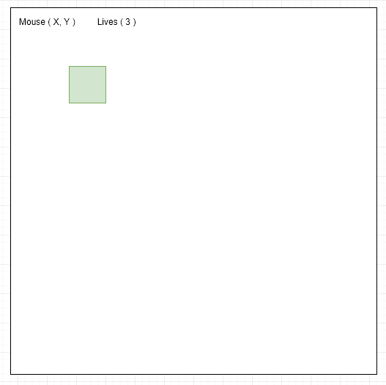

This wireframe shows what the first iteration of my game Trace Ball will look like. In this iteration. Only the players square is created and cannot be moved by the player. This prototype is meant to serve as a proof of concept that what I am creating is achievable and to serve as a foundation with which I can build on to create my game.

**Wireframe 2.1**

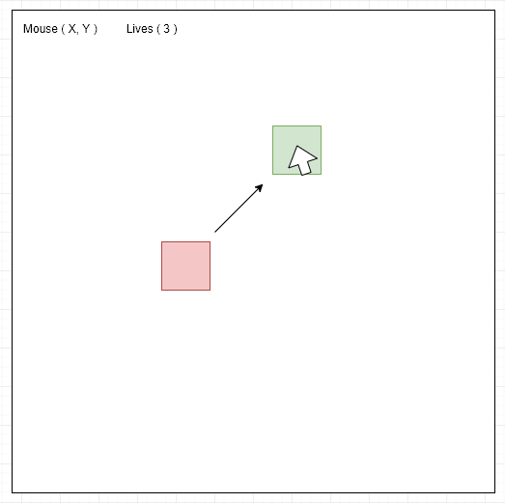

The first wireframe for my second prototype shows how the enemy square is now present and will chase the player around the playing area as indicated by an arrow pointing towards the player square. The mouse cursor over the player square shows that movement of the player character is now to be fully implemented .

**Wireframe 2.2**

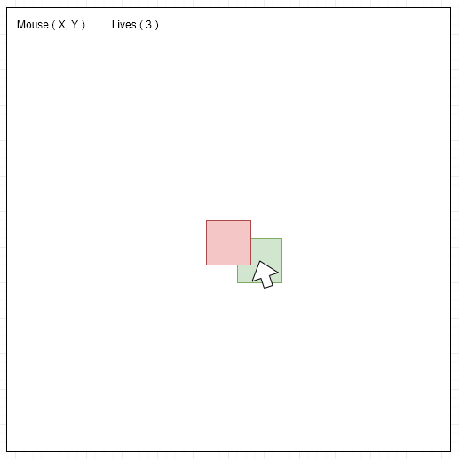

The second wireframe for my second prototype shows how there is not collision detection implemented in this version. Note how the users square does not change colour and the lives indicator on the top left has not changed.

**Wireframe 3**

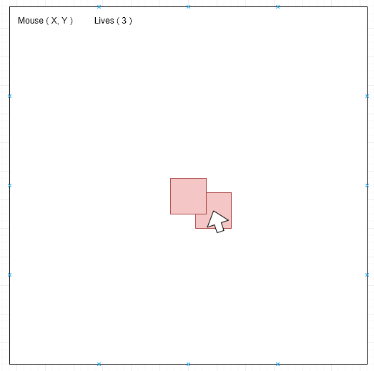

The wireframe for my third prototype version shows how collision detection will now be implemented. Note how the players square now changes colour from green to red to indicate to the user that they have collided with the enemy. The lives indicator now also changes every time they collide to provided an end to the game. A scoring system is yet to implemented.

**High Fidelity / Interactive Prototypes**

For my high fidelity prototypes I decided to create working, interactive prototypes in order to perform user tests. To create these prototypes I chose to use the online IDE repl.it. I chose to use this as It provided me with an integrated runtime environment so I could see changes in my prototypes during their creation. Also, with this software being online, I could work on these prototypes at any machine with internet access without having to worry about installing software. This was ideal for me as I found myself splitting my time working on these prototypes between home, class and in public places like libraries. In order to view these prototypes please go to my Github repository to download and run them. Or follow this link.